Institute Events 2018
Individual Registration Guidelines
A sample event, “Testing”, with a fee of $1 per participant was created in order to test the process and provide screenshots for your assistance. “Testing” is purely a representation of an event.

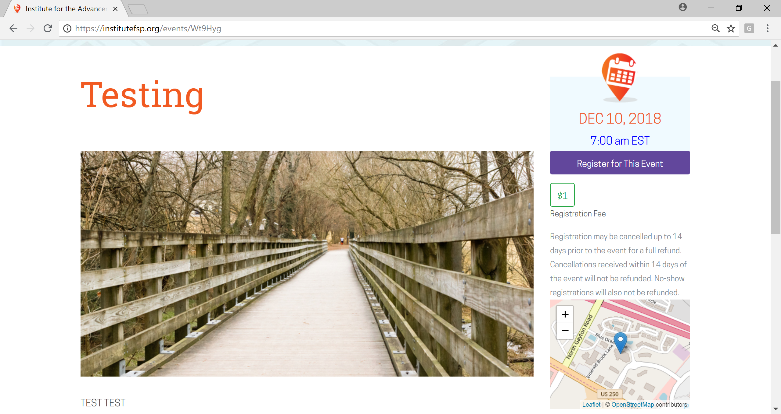

- Click on the purple box marked “Register for This Event” to begin the registration process. You will see a green box with the registration fee. Please note that registration can be cancelled up to 14 days prior to the event for a full refund. Cancellations received within 14 days of the event will NOT be refunded. No-show registrations will also NOT be refunded.

- (Below) You will be prompted on the next page to provide dietary restrictions and request special accommodations. After entering the applicable information, ensure that your name is correct before clicking on “Pay & Register as…”

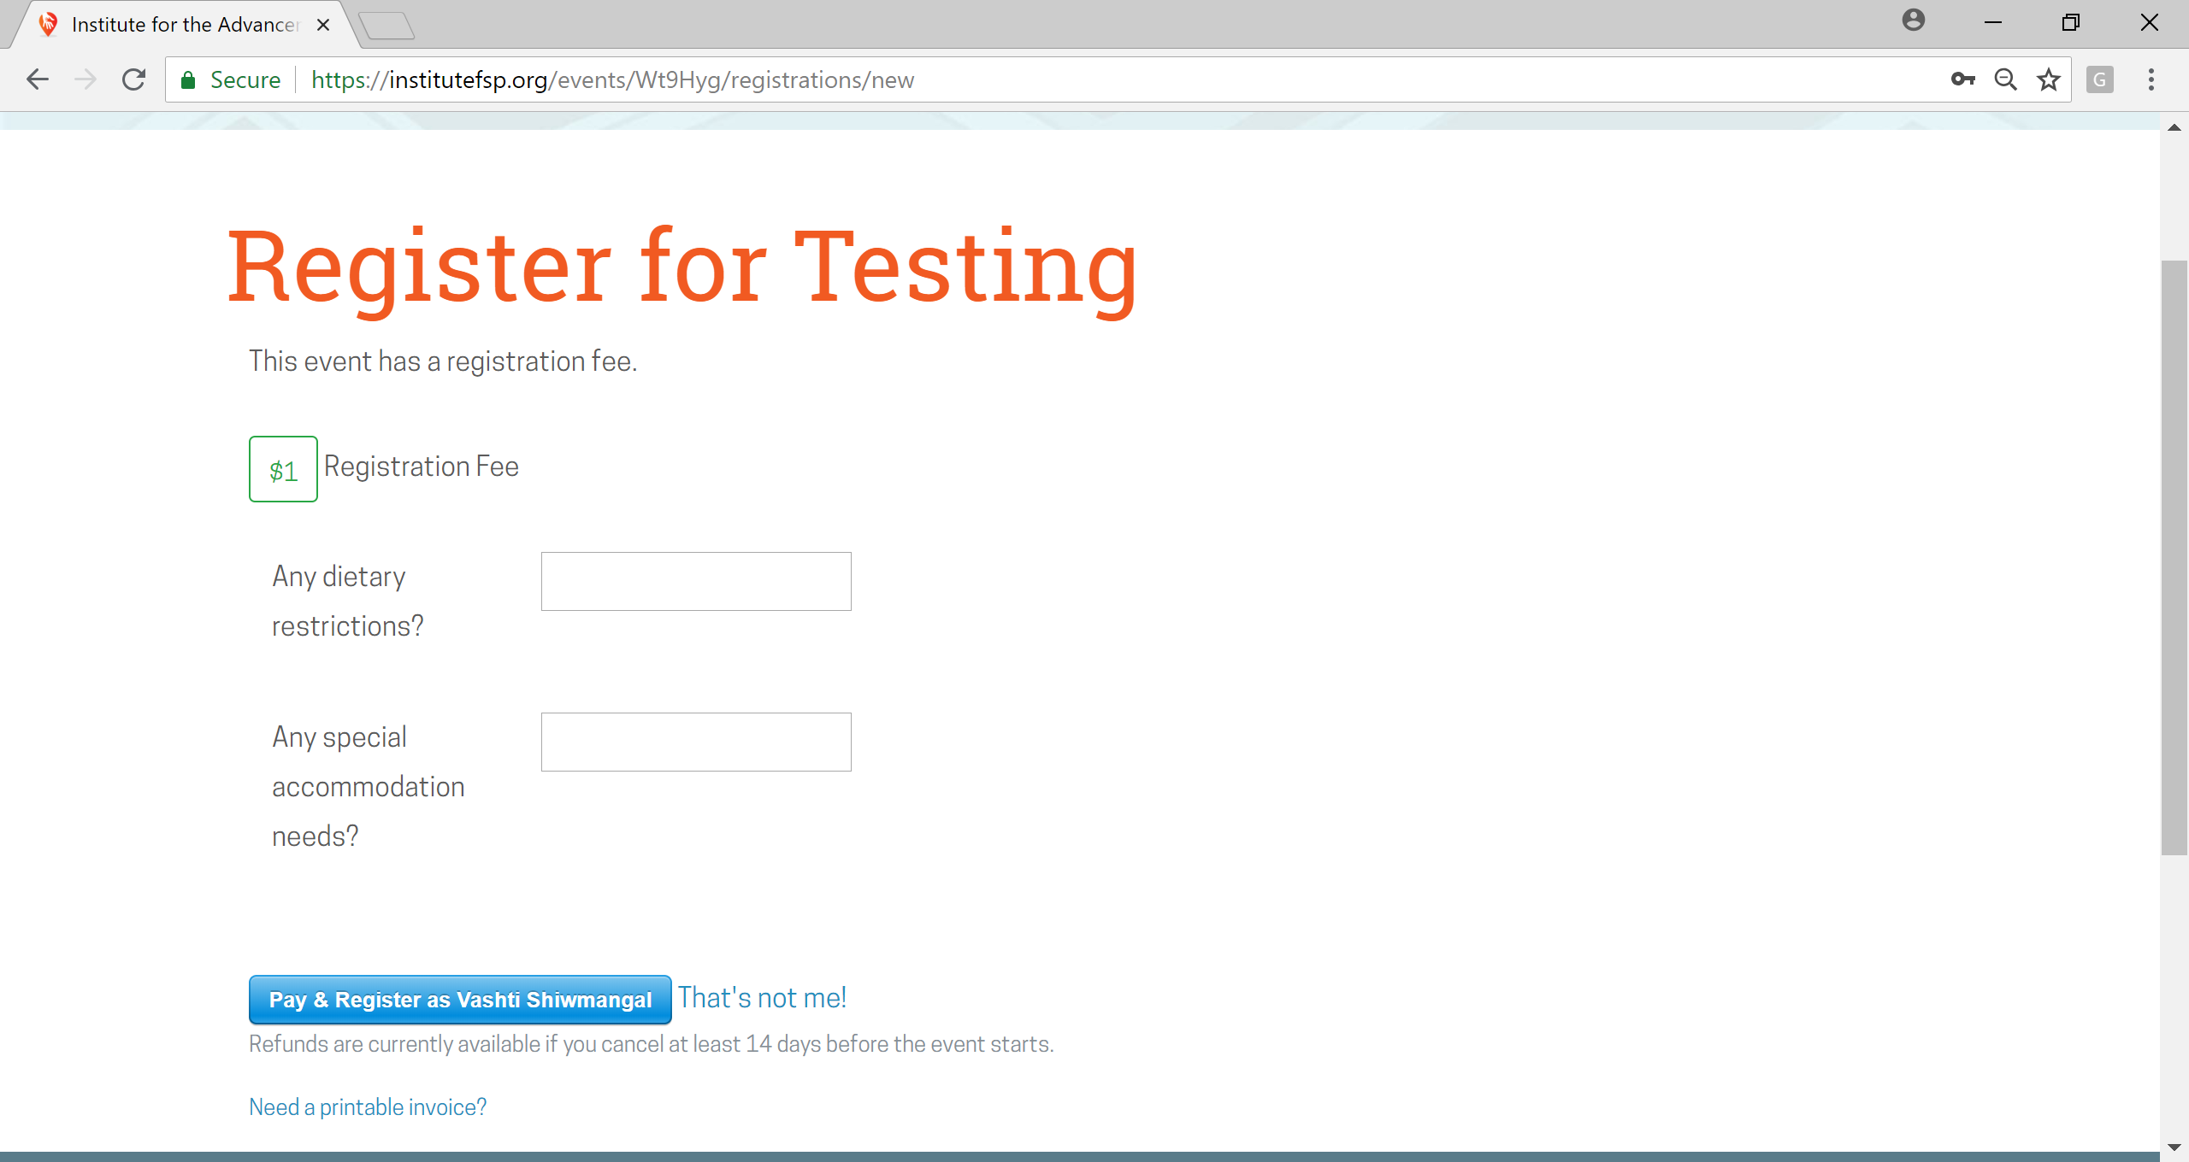
NOTE: If you MUST request a check through your organization instead of proceeding with a card payment, please email the registration contact.
Requesting an invoice does not save your seat(s), therefore we highly recommend you contact us as soon as possible. Once payment is received, you will be registered and notified with a confirmation email.

- If paying by card, please enter your card information in the three boxes above. Then, click on “Pay $___.” When your payment is complete, a green check mark appears.

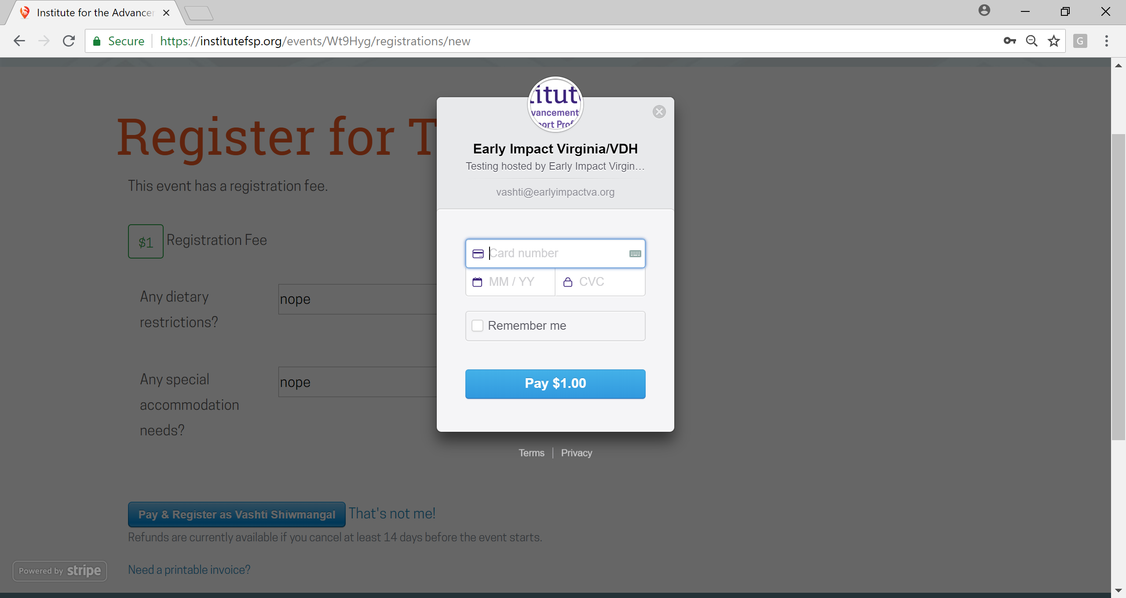

- You will be directed to this page, which may also be accessed by clicking on “Hi Name!” at the top right and then “My Events” in the left sidebar. The date can be saved on your calendar. You should also receive a Registration Confirmation from noreply@institutefsp.org with a short summary of the event (see below).
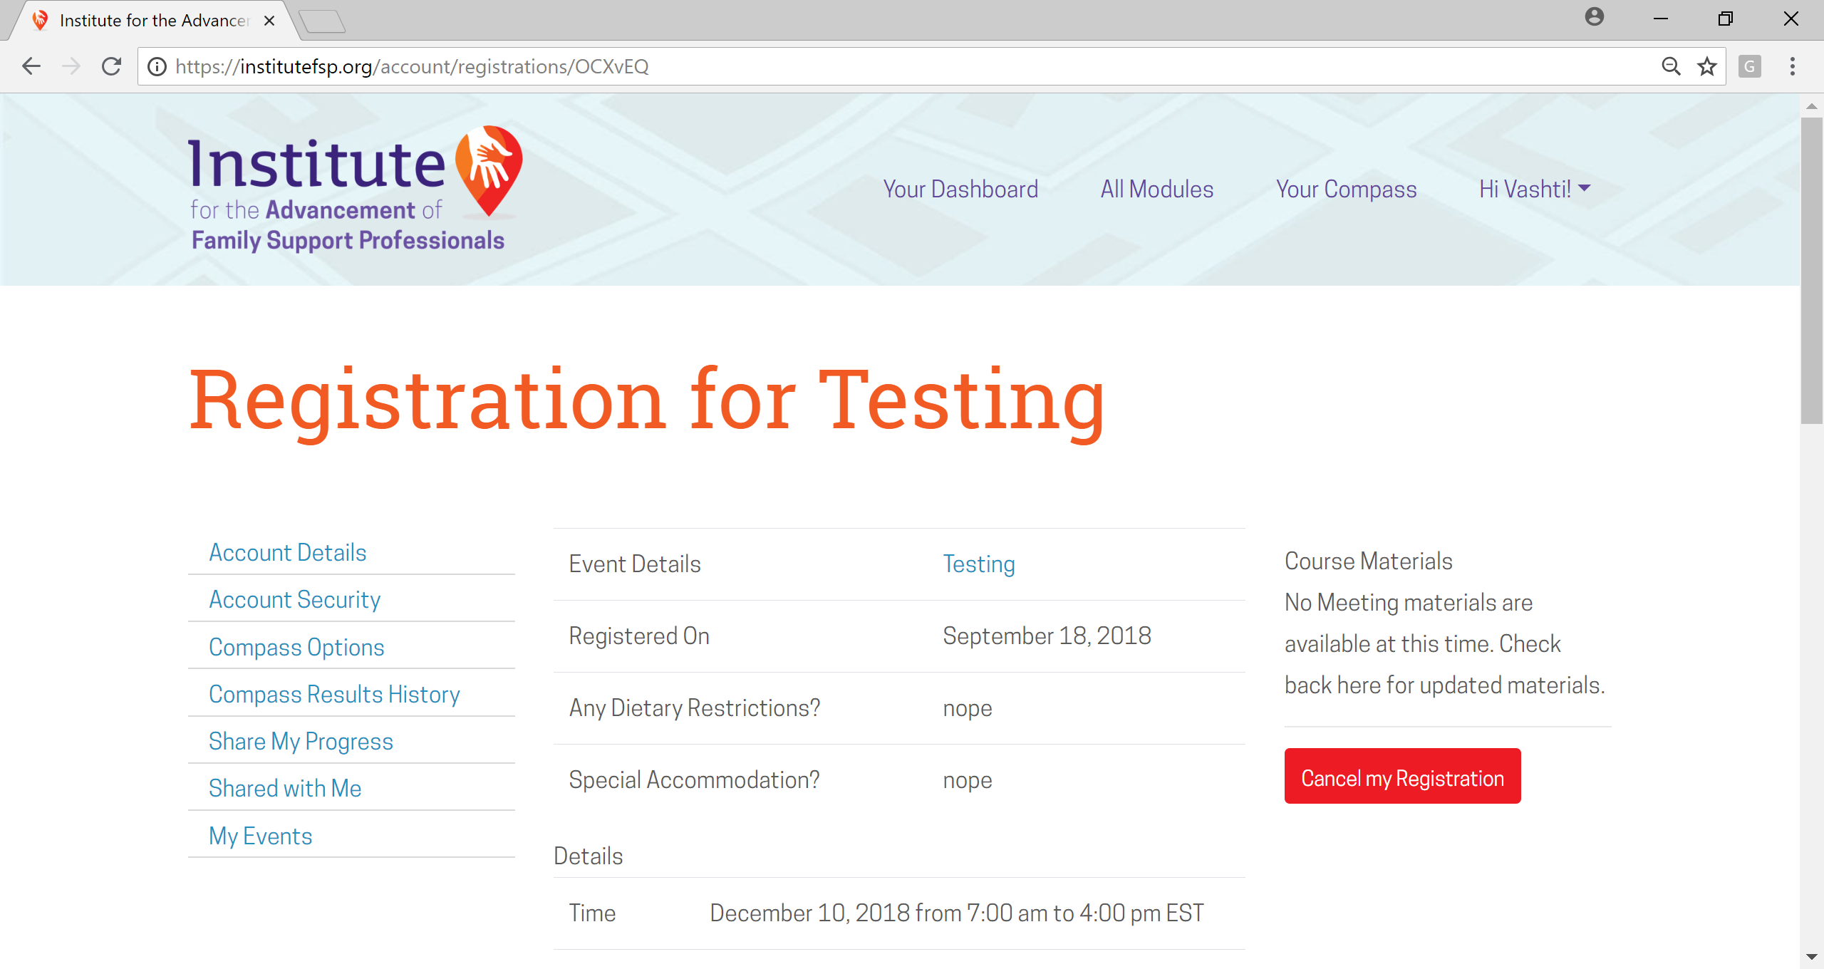

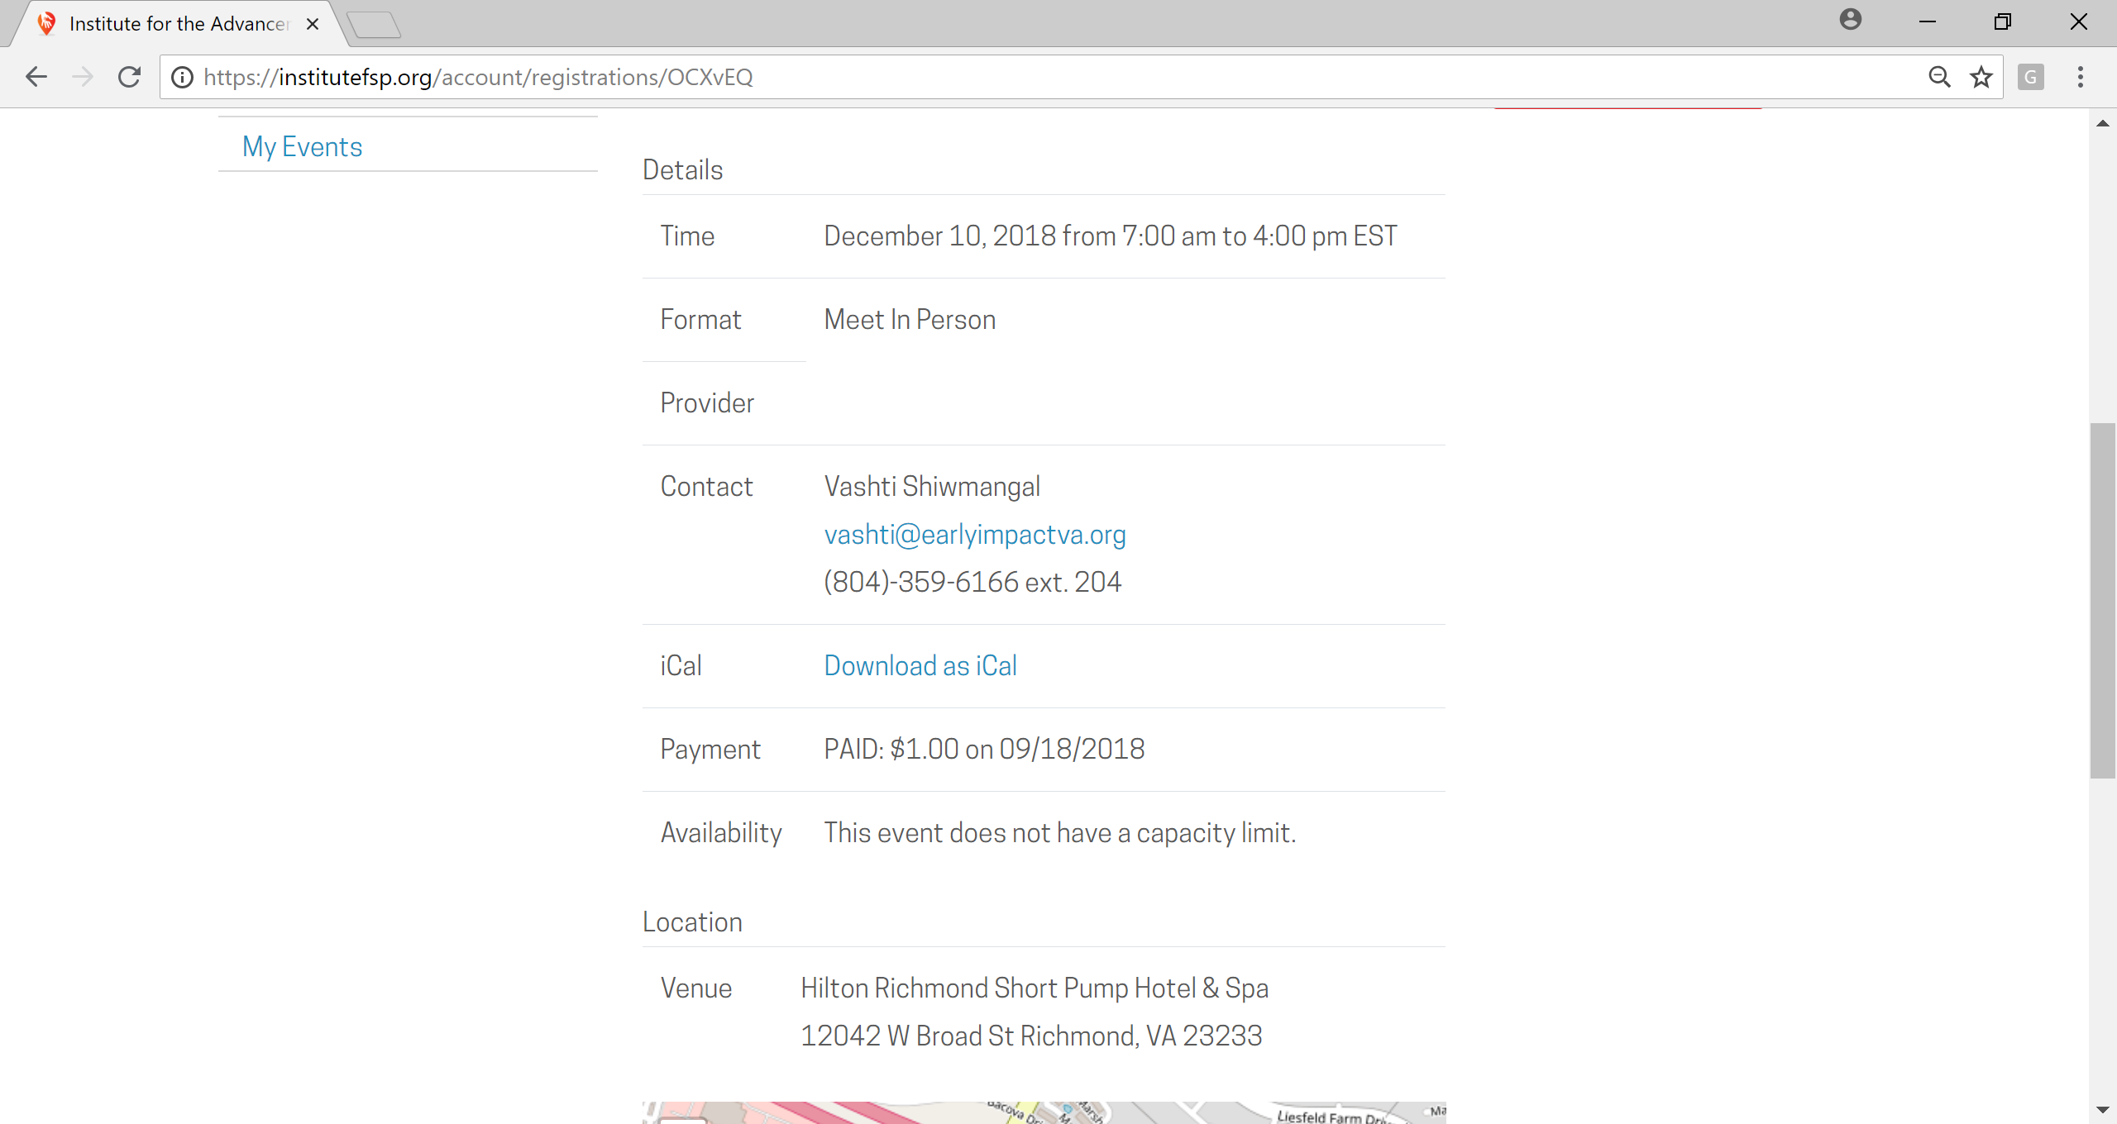

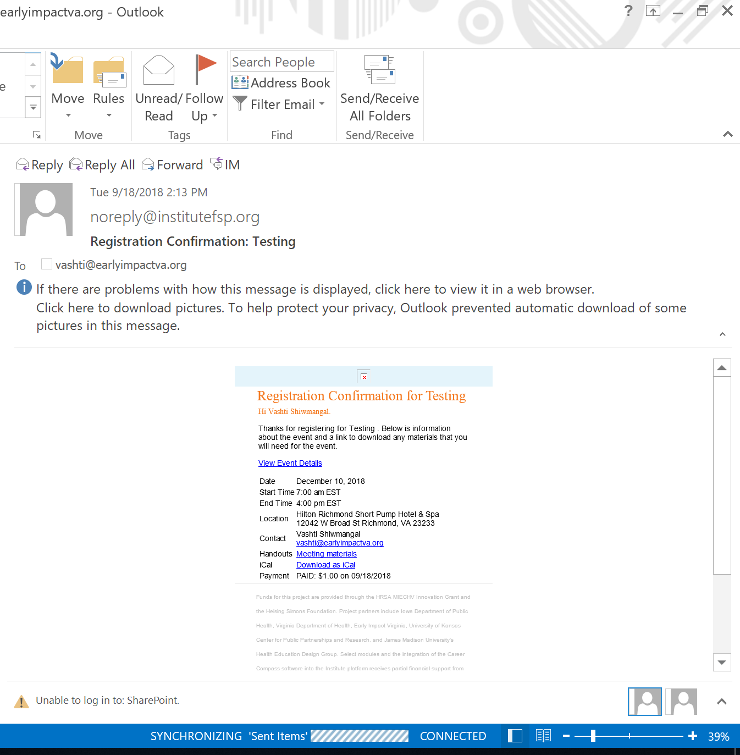
CANCELLATION:
To cancel registration, please click on “Cancel my Registration” in the red box. Again, registration can be cancelled up to 14 days prior to the event for a full refund. Cancellations received within 14 days of the event will NOT be refunded. No-show registrations will also NOT be refunded.
The event will be removed from your list of events. The Registration Contact will receive an email notification of your cancellation and can further confirm your cancellation.

