Virginia’s Premier Conference on Home Visiting
2018
Group Registration Guidelines
A sample event, “Testing”, with a fee of $1 per participant was created in order to test the process and provide screenshots for your assistance. “Testing” is purely a representation of the Conference event. The true Conference event, named “Virginia’s Premier Conference on Home Visiting,” will be used for registration.

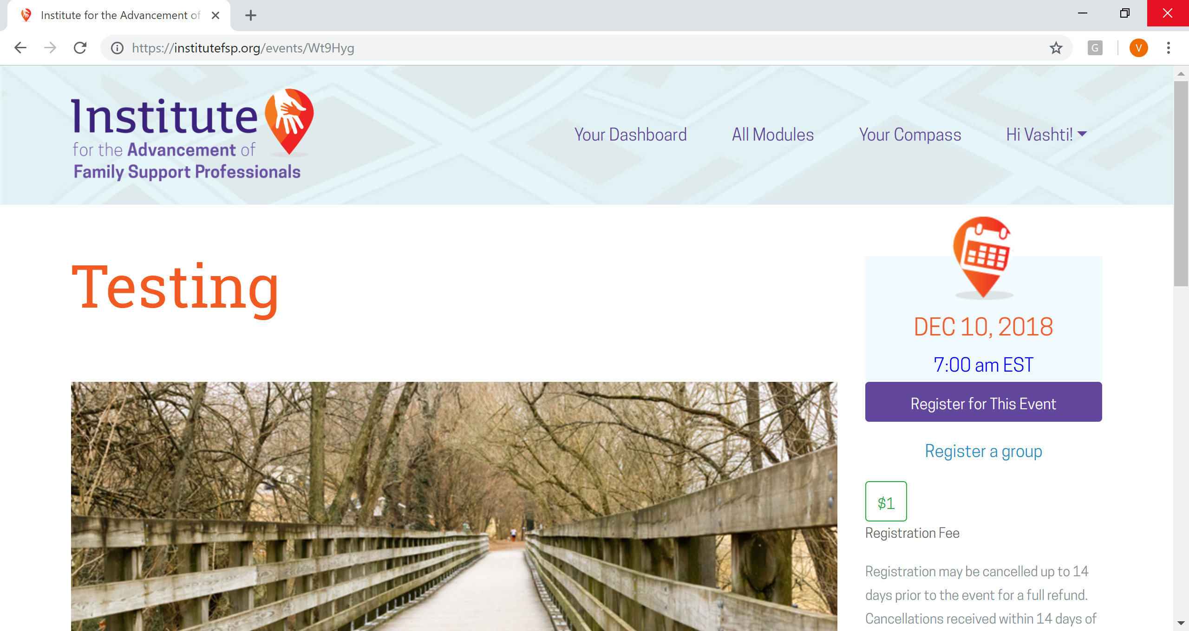

- Click on “Register a group” to begin the group registration process. You will see a green box with the registration fee. This registration fee is per individual. Please note that registration can be cancelled up to 14 days prior to the event for a full refund. The conference will take place on December 10th, therefore, please register prior to November 25th. Cancellations received within 14 days of the event will NOT be refunded. No-show registrations will also NOT be refunded.
- (Below) You will be prompted on the next page to provide name, emails, dietary restrictions and request special accommodations for each member of the group. After entering the applicable information for the specified person, click on “Add Registration.” As you add people, their names and information will appear below under “The following users will be registered for this event.” Then, click on “Next” to view the list of Potential Registrants.
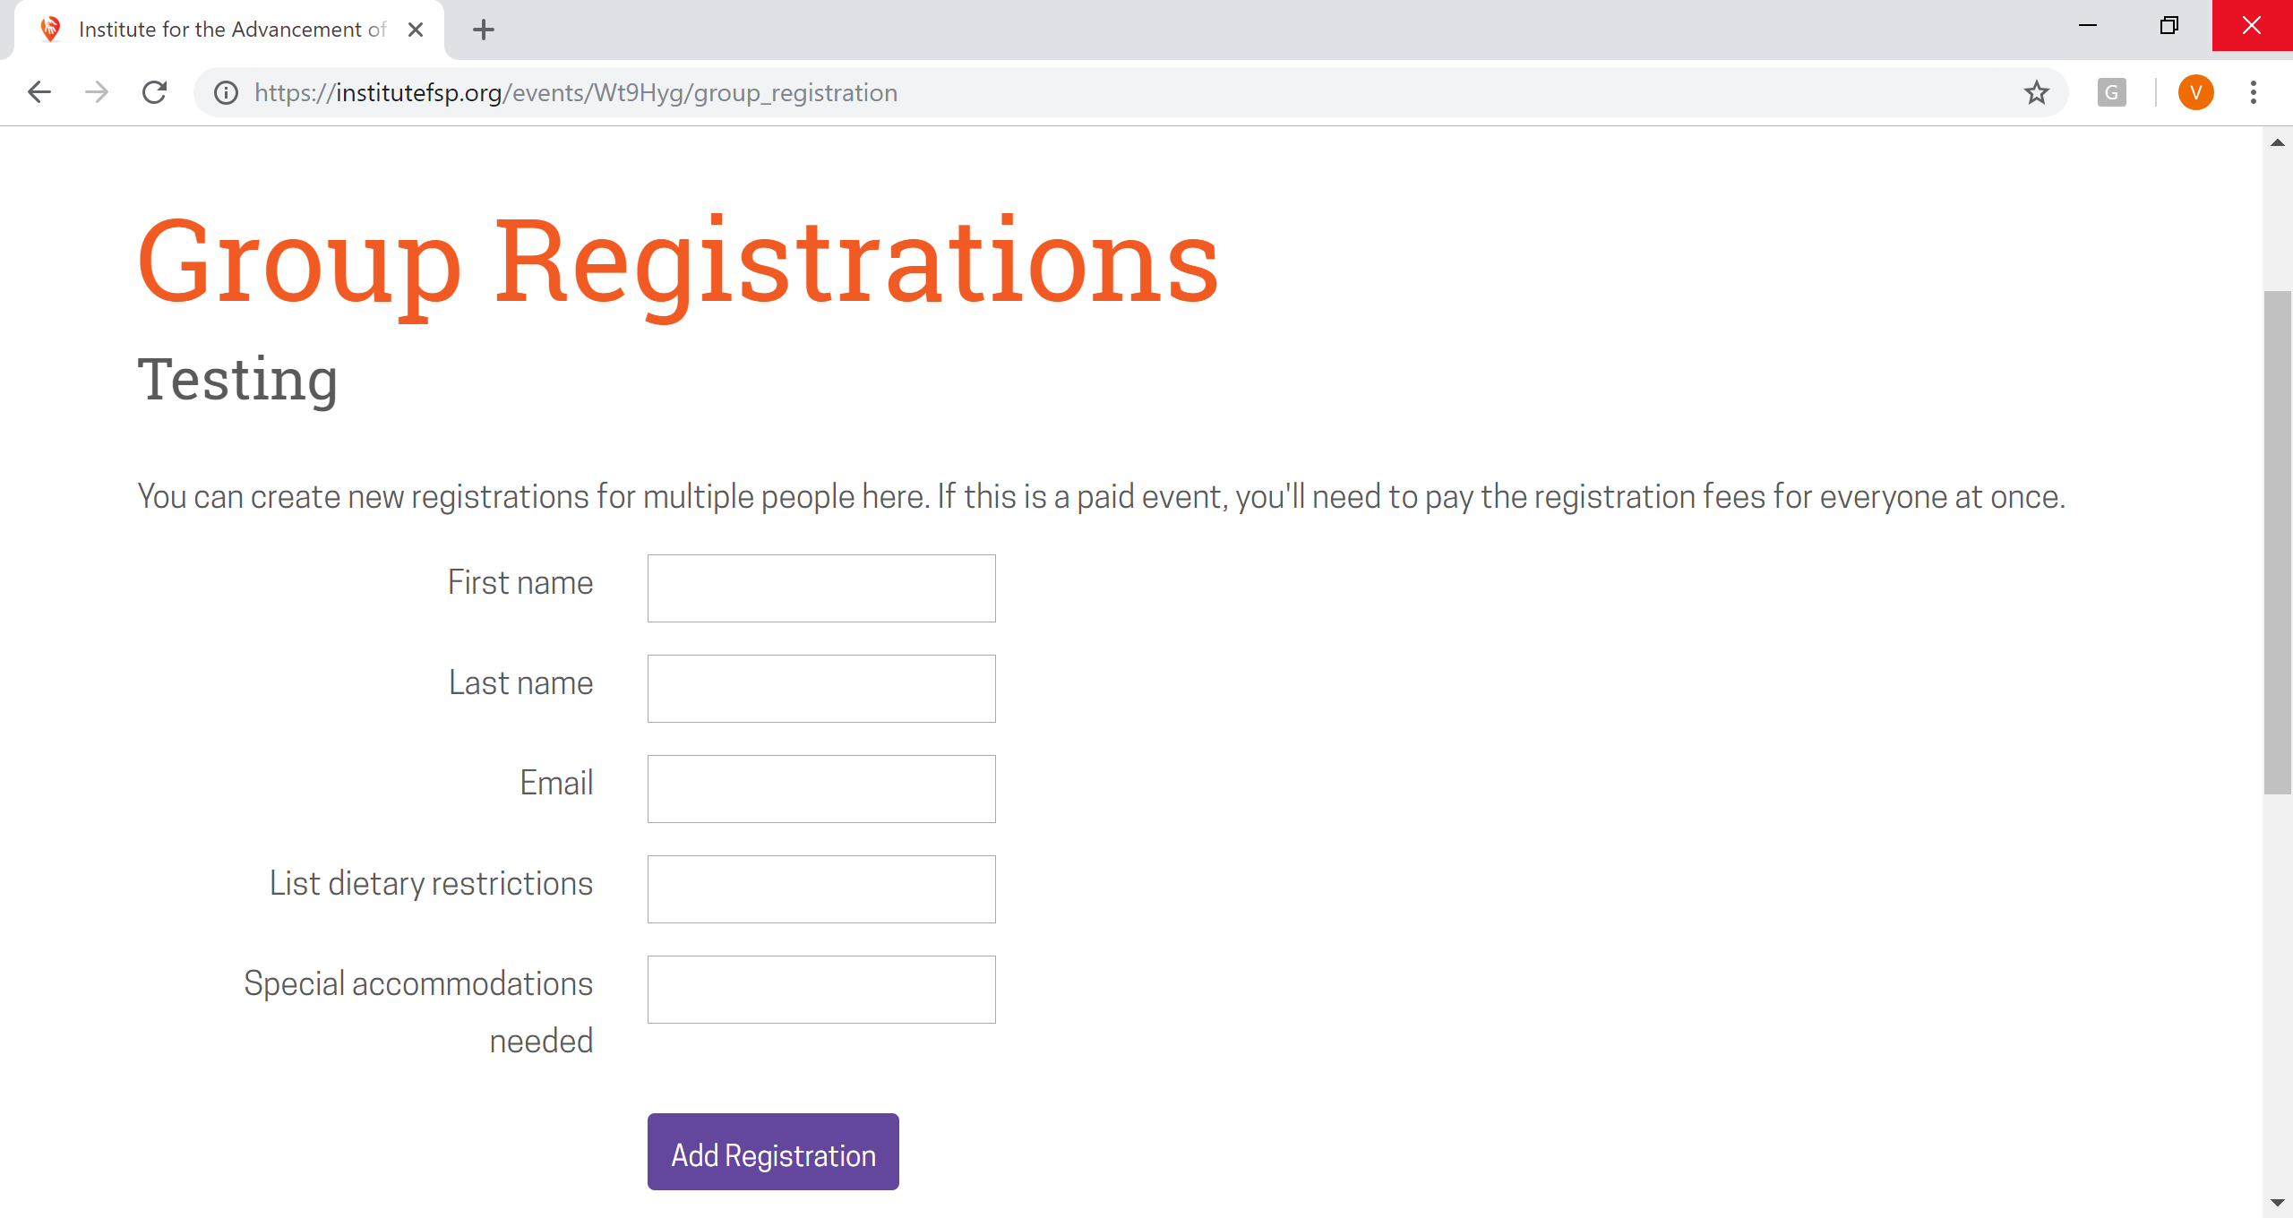

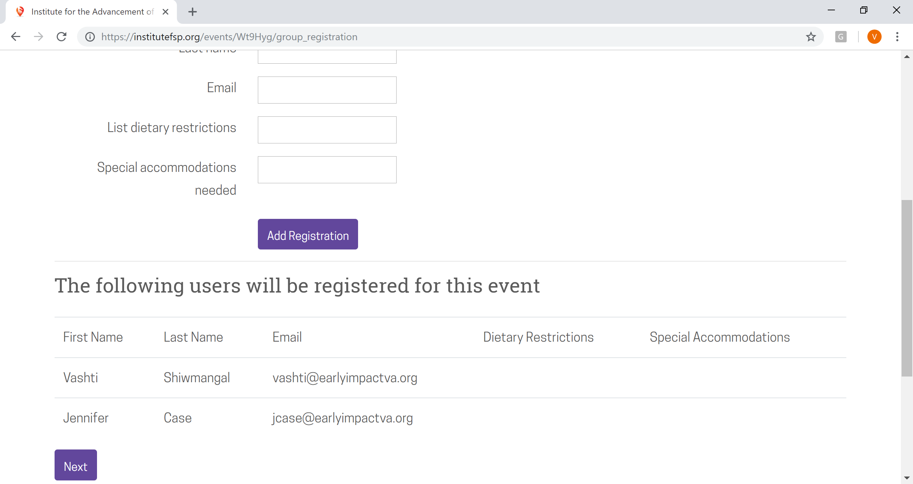

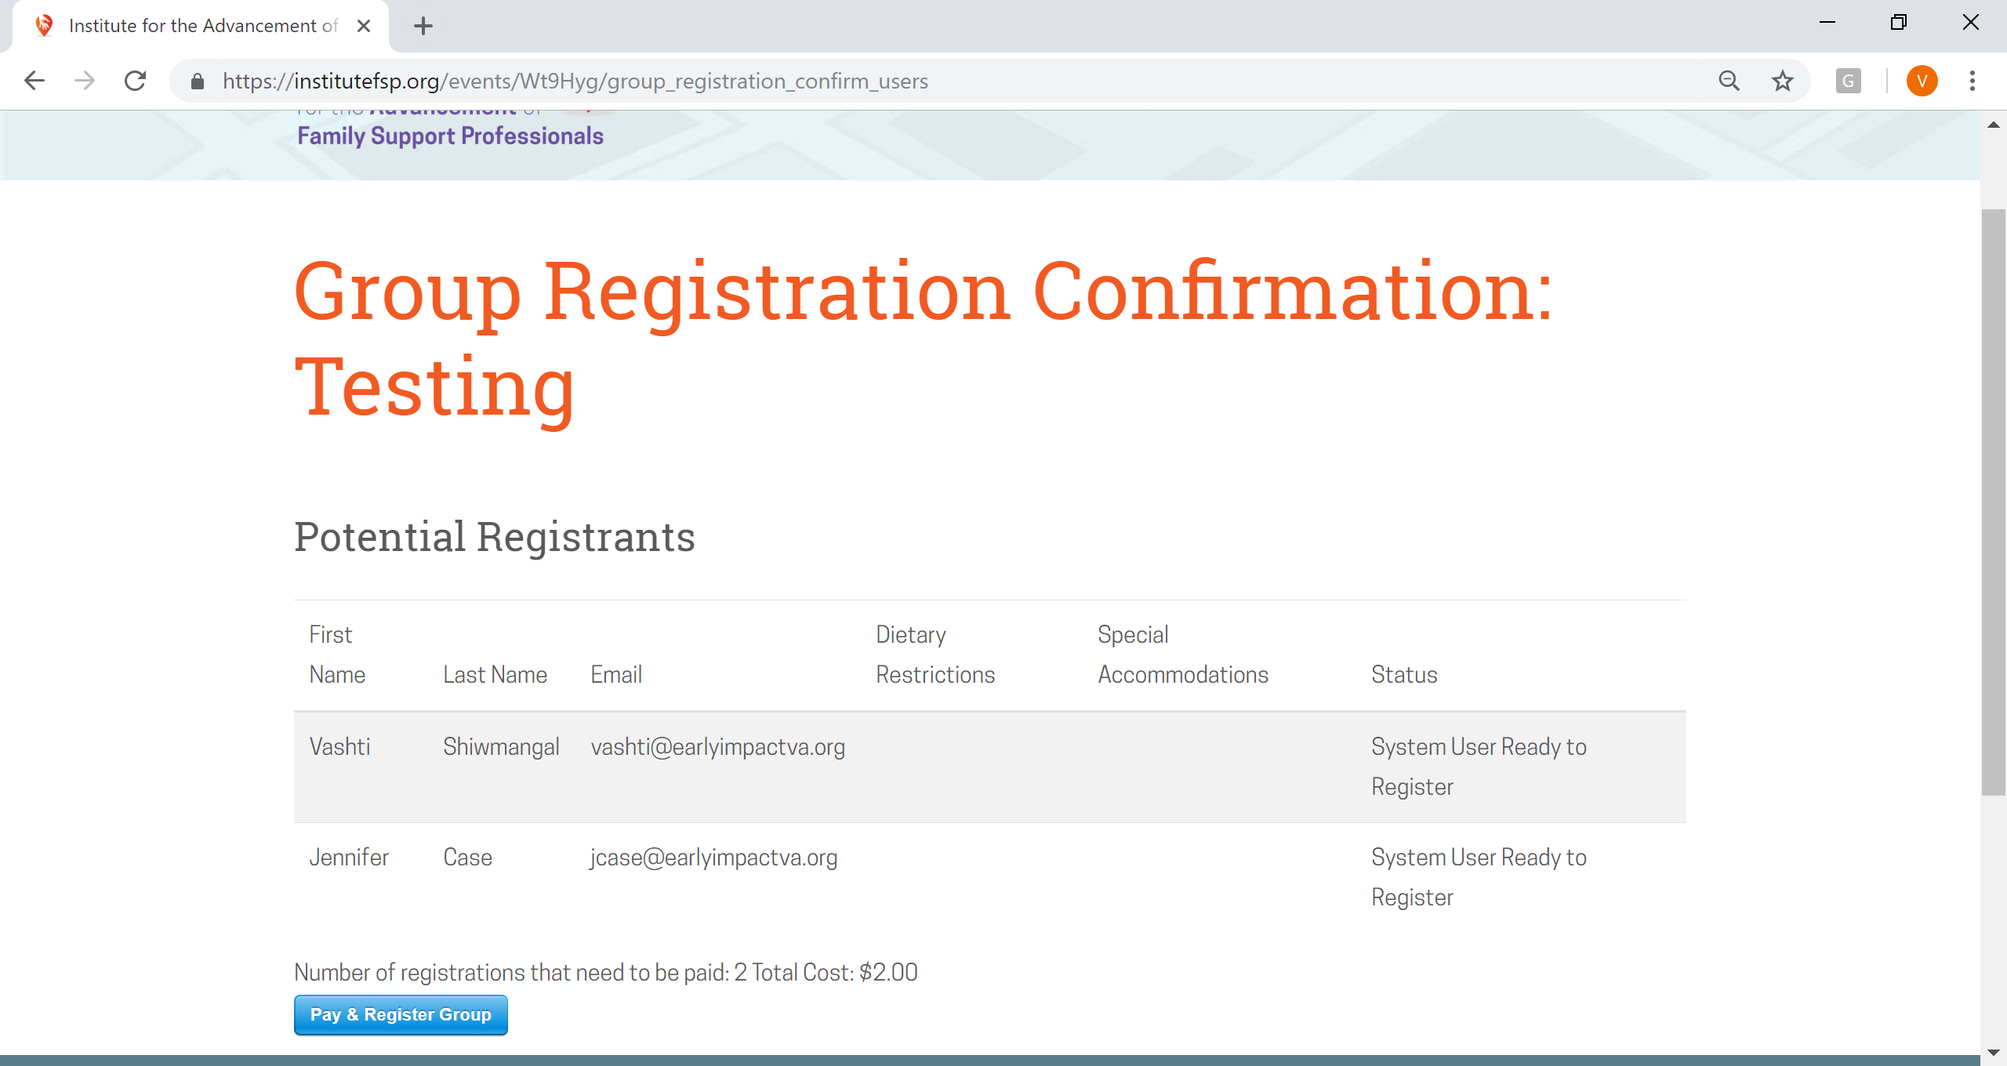

NOTE: If you MUST request a check through your organization instead of proceeding with a card payment, please email Vashti, Training Coordinator, at vashti@earlyimpactva.org
Requesting an invoice does not save your seat(s), therefore we highly recommend you contact us as soon as possible. Once payment is received, EIV will register all group members through the Institute and notify each member with a confirmation email.
- To proceed with card payment, ensure that all information is correct before clicking on “Pay & Register Group.” Your total number of registrations and cost will be stated above the blue “Pay & Register Group” box. Enter your Card information. Then, click on “Pay $___.” When your payment is complete, a green check mark appears.

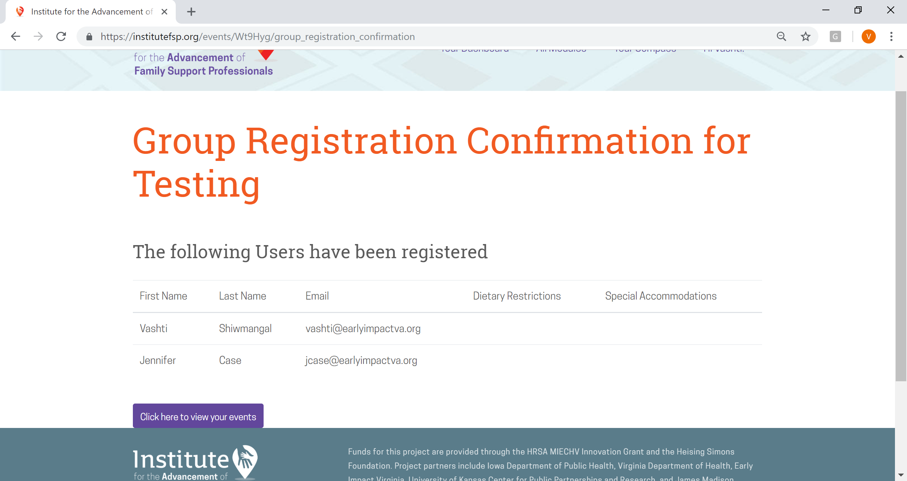

- “Click here to view your events” will take you to your account’s “My Events page. This page may also be accessed by clicking on “Hi Name!” at the top right and then “My Events” in the left sidebar. Clicking on the event name (i.e. “Testing”) will take you to a summary page (see below). The date can be saved on your calendar. Each registered group member should also receive a Registration Confirmation from noreply@institutefsp.org with a short summary of the event.
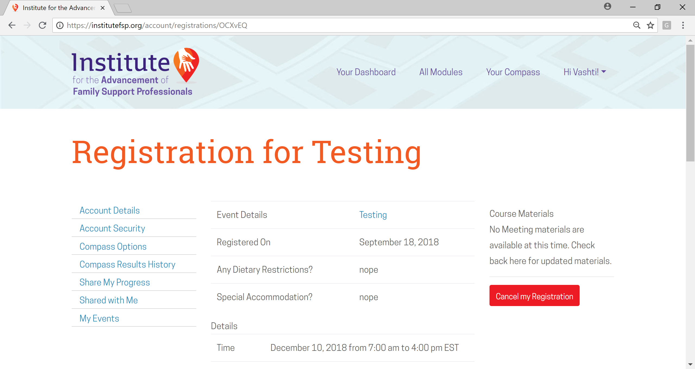

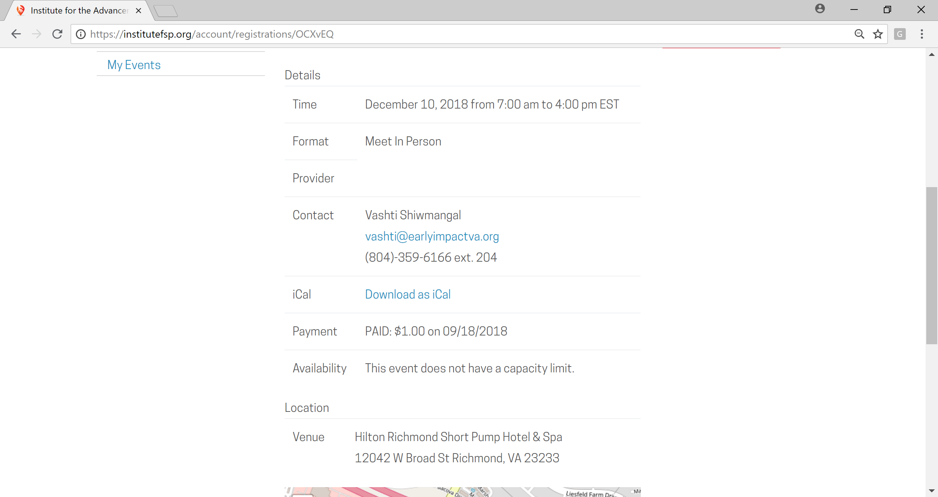

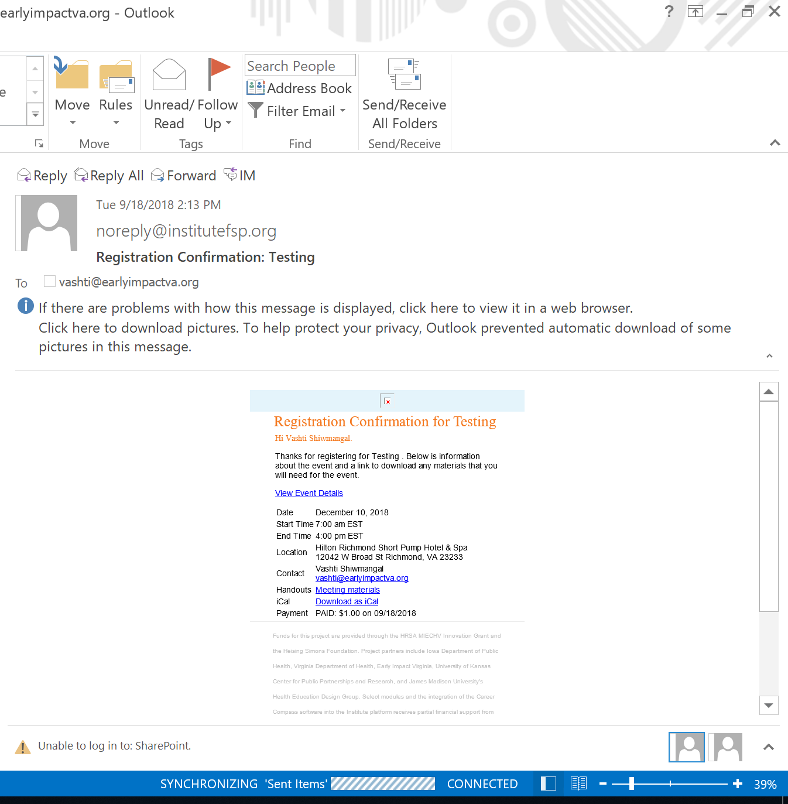

CANCELLATION:
While you may have registered as a group, cancellation must be completed on an individual basis. Individual cancellations will not affect the registration status of other group members.
To cancel registration, please go to your “My Events page” and click on “Cancel my Registration” in the red box. Again, registration can be cancelled up to 14 days prior to the event for a full refund. The conference will take place on December 10th, therefore, please register prior to November 25th. Cancellations received within 14 days of the event will NOT be refunded. No-show registrations will also NOT be refunded.
The event will be removed from your list of events. Vashti Shiwmangal, the EIV Training Coordinator and Conference Registration Contact will receive an email notification of your cancellation and can further confirm your cancellation.

Thank you and we hope to see you on December 10th!

