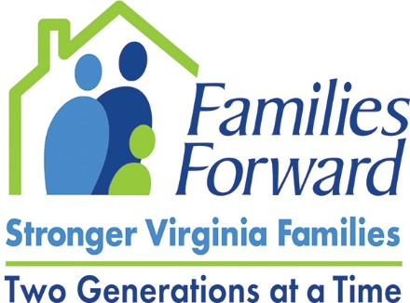
VIRTUAL VISIT WITH PARENTS
2021 Virginia General Assembly
Program Agenda

- WELCOME to the Virtual Parent Town Hall and Introductions. (1 minute)

- What’s happening at the Capitol? Which elected officials will be joining us? (1 minute)

- QUICK ICEBREAKER: What is your current favorite song? (3-4 minutes)

- FIRST ROUND: (10 minutes)
  - Tell us about you and your family?
  - When did you get connected to home visiting?
  - How has home visiting been helpful during the pandemic?

- SECOND ROUND: (15 minutes)
  - What supports are most helpful to you as a parent?
  - What’s most helpful for your child?
  - What barriers keep you from getting these supports?

- SHORT VIDEO clip about home visiting (2-4 mins)

- OUR PLAN to expand home visiting to more parents in Virginia (2 minutes)

- DISCUSS any other issues parents brought up (5 minutes)

- CONCLUDING REMARKS from Parents (5 minutes)

